##### CIRCUIT_BREAKERS



## A Project Report on

## “Smart Forest Fire Detection System”

*Submitted in partial fulfillment of requirements for the*

## HackFest 2023

## in

## Category-1: ELECTRONICS

*Submitted by*

**CIRCUIT_BREAKERS**



**DECLARATION**

We hereby declare that the entire project work entitled **“Smart Forest Fire Detection System”** is a project report of the original work done by our team “**Circuit_Breakers**” for HackFest 2023 and to best of our knowledge and belief, no part of it has been submitted for any degree or diploma of any institution previously.

**Place: Bengaluru** Signature

##### Date: 29/06/2023

**CONTENT**

| **CHAPTER NO.** | **TITLE** | **PAGE NO.** |
| --- | --- | --- |
| **1** | **INTRODUCTION** | **1** |
| **2** | **SPECIAL KEYWORDS** | **2** |
| **3** | **OBJECTIVE** | **3** |
| **4** | **HARDWARE IMPLEMENTATION** | **5** |
| 4.1 | Sensors | 5 |
| 4.2 | HC-12 Module | 6 |
| 4.3 | A9G Module | 7 |
| 4.4 | ATmega328P Microprocessor | 8 |
| 4.5 | Solar Panels | 9 |
| 4.6 | Node MCU | 10 |
| **5** | **SOFTWARE IMPLEMENTATION** | **13-14** |
| 5.1 | Google Firebase |  |
| 5.2 | Mobile App |  |
| 5.3 | Telegram Chatbot |  |
| 5.4 | Web Server |  |
| **6** | **WORKING** | **17-18** |
| **7** | **ADVANTAGES** | **23** |
| **8** | **FUTURE PROSPECTS** | **24** |
| **9** | **VERSION 2.0** | **25** |
| **10** | **CONCLUSION** | **26** |

# 

# CHAPTER-1

# INTRODUCTION

A forest fire management system is a comprehensive approach that aims to prevent, detect, monitor, and respond to forest fires in an efficient and effective manner. It involves the implementation of various strategies, technologies, and policies to minimize the impact of wildfires on forests, wildlife, communities, and the environment.

The system typically consists of several key components:

1. **Prevention:** Forest fire prevention involves activities such as creating fire breaks, conducting controlled burns, promoting public awareness campaigns, and implementing regulations and restrictions on activities that could potentially ignite fires, such as campfires or certain industrial practices.
2. **Detection:** Early detection of forest fires is crucial for prompt response and containment. Modern forest fire management systems employ various techniques for fire detection, including aerial surveillance, satellite imagery, remote sensing technologies, weather monitoring, and the use of specialized sensors and cameras placed strategically in fire-prone areas.
3. **Monitoring:** Continuous monitoring of forest areas helps to assess fire risk, track fire behavior, and predict fire spread. This may involve the use of weather monitoring stations, real-time data analysis, and the integration of advanced modeling and simulation tools to generate accurate predictions and warnings.
4. **Communication and Coordination:** Effective communication and coordination among various stakeholders, including fire departments, emergency services, forest management agencies, and local communities, are essential. This ensures timely and coordinated responses, efficient allocation of resources, evacuation plans, and dissemination of information to the public.
5. **Response and Suppression:** Once a forest fire is detected, rapid response and suppression efforts are initiated. This includes mobilizing firefighting personnel, deploying fire suppression equipment, and utilizing aerial resources such as helicopters and planes for water or fire retardant drops. The system may also incorporate strategies like controlled burns or the creation of firebreaks to contain and mitigate the fire's spread.
6. **Post-Fire Rehabilitation:** After a fire is extinguished, rehabilitation and recovery efforts take place. This involves assessing the damage to the ecosystem, implementing measures to prevent soil erosion, promoting natural regeneration, and planning for reforestation or restoration activities.

# CHAPTER-2

# SPECIAL KEYWORDS

|  |  |
| --- | --- |
| **Abbreviations** | **Full form** |
| DC | Direct Current |
| MCU | Microcontroller Unit |
| GPS | Global Positioning System |
| Wi-Fi | Wireless Fidelity |
| HTTP | Hyper Text Transfer Protocol |
| DIY | Do It Yourself |
| GSM | Global System for Mobile |
| SMS | Short Message Service |
| IoT | Internet of Things |

**CHAPTER-3**

# OBJECTIVE

The objective of the Forest Fire Management System is to prevent, monitor, and effectively respond to forest fires to mitigate their impact on ecosystems, human lives, and property. This comprehensive system aims to enhance early detection capabilities, facilitate rapid and coordinated response efforts, and promote sustainable forest management practices. By implementing advanced technologies, such as remote sensing, real-time data analysis, and predictive modeling, the system aims to improve the accuracy and timeliness of fire detection, enabling early intervention to suppress fires before they escalate. Furthermore, the system seeks to promote public awareness, education, and community engagement to foster a culture of fire prevention and responsible forest use. Ultimately, the Forest Fire Management System strives to protect and preserve forest resources, minimize environmental damage, and ensure the safety and well-being of both natural ecosystems and human populations.

**CHAPTER-4**

# HARDWARE IMPLEMENTATION

# 4.1 Sensors:

# KY-026 (flame sensor) - a compact electronic module designed to detect the presence of flames or fire. It utilizes an infrared (IR) sensor that is sensitive to the wavelengths emitted by flames. When a flame is detected within its range, the sensor outputs a digital signal, indicating the presence of fire. The KY-026 flame sensor is commonly used in various applications, including fire alarm systems, fire-fighting robots, and industrial safety devices. Its small size and simple interface make it easy to integrate into different projects, providing a reliable means of detecting flames and initiating appropriate actions to ensure safety.

# DHT11 (temp. & humidity sensor) - a popular and affordable digital temperature and humidity sensor widely used in various applications. It consists of a capacitive humidity sensor and a thermistor for temperature measurement. The DHT11 sensor provides accurate readings with a temperature range of 0 to 50 degrees Celsius and a humidity range of 20% to 90%. With its simple three-pin interface, it can be easily connected to microcontrollers and single-board computers, making it a popular choice for DIY electronics projects and environmental monitoring systems. The sensor communicates using a single-wire digital protocol, making it straightforward to integrate into existing circuits. Its low cost, simplicity, and reliable performance make the DHT11 sensor a versatile choice for temperature and humidity sensing in a wide range of applications.

# MQ7 (CO sensor) - a compact and versatile gas sensor widely used for detecting carbon monoxide (CO) in various environments. It operates on the principle of catalytic combustion, utilizing a small heating element to raise the temperature of the sensor's sensitive material. As carbon monoxide meets the sensor, it undergoes an oxidation reaction, leading to a change in electrical conductivity. This change is measured and used to determine the presence and concentration of CO in the surrounding air. The MQ7 sensor offers a quick response time, high sensitivity, and low power consumption, making it suitable for applications in safety systems, industrial environments, and residential settings where carbon monoxide detection is crucial. Its compact size and affordability make it a popular choice among engineers and researchers for gas sensing purposes.

## 

## Flame sensor (KY-026) Temp. & Humidity sensor Carbon Monoxide (CO) sensor (MQ7)

## (DHT11)

**4.2 HC-12 Module:**

The HC-12 module is a wireless transceiver module that provides a simple and cost-effective solution for wireless communication. It operates on the 433MHz frequency band and offers reliable long-range communication with low power consumption. The module is commonly used in various applications such as remote-control systems, wireless data transmission, telemetry, and more.

Frequency: The HC-12 module operates on the 433MHz ISM (Industrial, Scientific, and Medical) band, which allows for longer-range communication compared to higher frequency bands. It offers a maximum communication range of up to several kilometers in open space.

Serial Communication: The module uses a serial communication interface to connect with microcontrollers or other devices. It supports standard UART (Universal Asynchronous Receiver-Transmitter) communication protocol, making it compatible with a wide range of microcontrollers, such as Arduino, Raspberry Pi, and others.

Adjustable Power: The HC-12 module provides adjustable transmit power levels, allowing you to optimize the range and power consumption based on your specific requirements. It offers a maximum output power of 100mW (20dBm) and can be configured to operate at lower power levels to conserve energy.

Data Rate: The module supports a data rate of up to 115.2 kbps, enabling the transmission of moderate amounts of data quickly and efficiently. However, it's important to note that higher data rates may reduce the effective communication range.

Operating Modes: The HC-12 module offers multiple operating modes to suit different applications. It supports transparent mode, in which the module acts as a wireless serial link, transparently transmitting data between two connected devices. It also supports a command mode, which allows you to configure various parameters of the module through simple AT commands.

Error Correction: The module incorporates a built-in error correction mechanism to enhance the reliability of data transmission. It uses forward error correction (FEC) to detect and correct errors during data transmission, thereby reducing the chances of data corruption.

Power Supply: The HC-12 module operates at a voltage range of 3.2V to 5.5V, making it compatible with a wide range of power supplies. It consumes relatively low power, especially when operating in low-power modes, making it suitable for battery-powered applications.

Antenna: The module requires an external antenna for optimal performance. It features an onboard U.FL connector for connecting an external antenna, allowing you to choose the appropriate antenna based on your specific needs and communication range requirements.

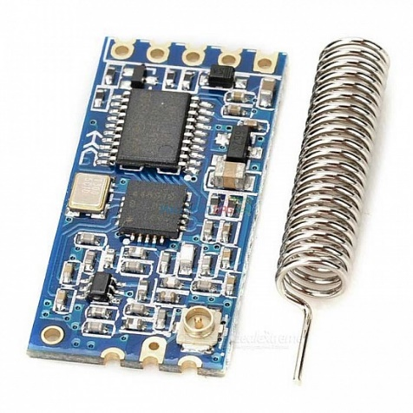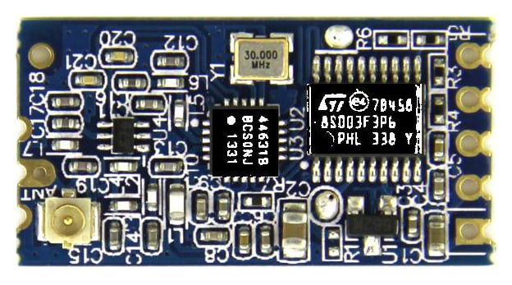

# NodeHub:

## 4.3 A9G Module -

The A9G module is powered by the AI-Thinker A9G system-on-chip (SoC), which integrates a 32-bit microcontroller unit (MCU) along with a quad-band GSM/GPRS modem. This combination enables the A9G module to not only handle cellular communication but also execute complex tasks and run user applications directly on the module. One of the standout features of the A9G module is its support for various communication protocols, including GSM, GPRS, and GPS. This makes it suitable for a wide range of IoT applications such as asset tracking, remote monitoring, fleet management, and more. The integrated GPS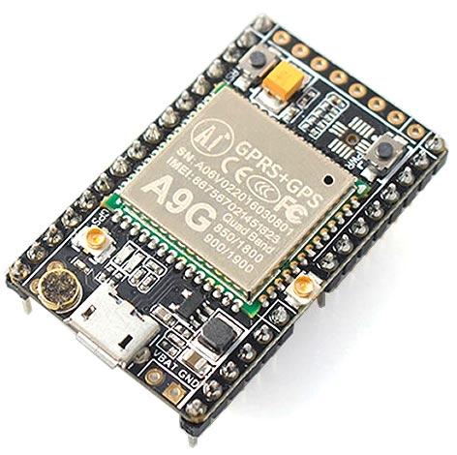 receiver allows for accurate positioning and location-based services, enhancing the module's capabilities further.

In terms of connectivity, the A9G module supports multiple interfaces, including UART, SPI, I2C, and GPIO, providing flexibility for connecting with external sensors, actuators, and other peripheral devices. This makes it a versatile choice for IoT projects that require interaction with a diverse range of sensors or external systems. The A9G module also features a built-in TCP/IP stack, allowing for seamless internet connectivity. This enables the module to communicate with remote servers, cloud platforms, or other IoT devices over the internet, opening possibilities for data exchange, remote control, and cloud-based applications.

## 4.4 ATmega328P microprocessor -

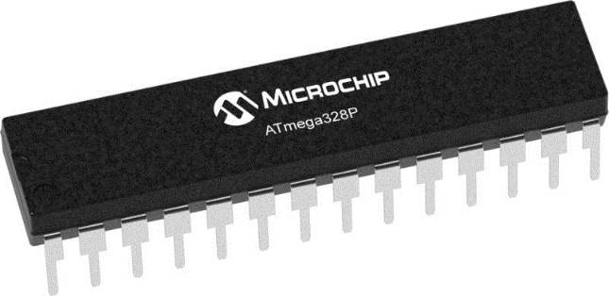The ATmega328 module is a versatile and powerful microcontroller unit that is widely used in various electronic projects and applications. Based on the AVR (Advanced Virtual RISC) architecture. The ATmega328P is based on an enhanced RISC (Reduced Instruction Set Computer) architecture and operates at a maximum frequency of 20 MHz. It features 32 kilobytes of flash memory, which is used for storing the program code, and 2 kilobytes of SRAM (Static Random Access Memory) for data storage. Additionally, it has 1 kilobyte of EEPROM (Electrically Erasable Programmable Read-Only Memory) that allows for non-volatile data storage. One of the notable features of the ATmega328P is its rich set of peripherals. It has 23 general-purpose I/O pins, which can be configured as inputs or outputs to interface with various external devices. These pins can also support several communication protocols, including UART (Universal Asynchronous Receiver Transmitter), SPI (Serial Peripheral Interface), and I2C (Inter-Integrated Circuit).

The microcontroller incorporates a 10-bit analog-to-digital converter (ADC) with up to 8 channels, enabling it to read analog signals from sensors or other analog devices. This feature is particularly useful in applications where analog data needs to be converted into digital format for processing. The ATmega328P supports different power-saving modes, including idle, ADC noise reduction, power-down, and standby.

## 4.5 Solar Panels:

Small solar panels, also known as photovoltaic cells, are compact and efficient devices that convert sunlight into electrical energy. These panels are commonly used in various devices to power or supplement their energy needs. Due to their small size, they are often integrated into portable electronics such as calculators,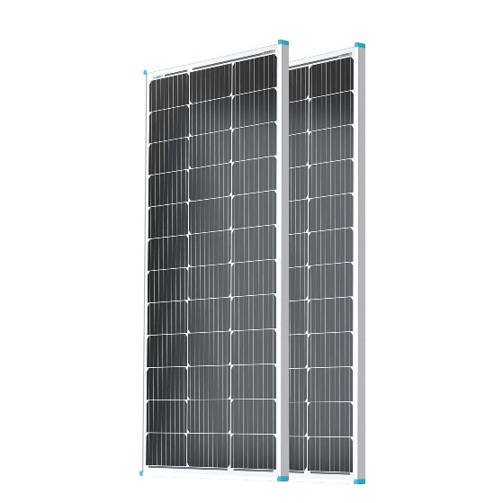 watches, and outdoor gadgets like solar-powered flashlights or phone chargers. These panels typically consist of multiple interconnected solar cells, which work by absorbing photons from sunlight and generating an electric current through a photovoltaic effect. Small solar panels are a sustainable and renewable energy solution, enabling devices to operate in remote locations without relying on traditional power sources and reducing the environmental impact of their operation.

## 4.6 NodeMCU:

## One of the key advantages of the NodeMCU is its ease of use and programming. It can be programmed using the Arduino IDE, which makes it accessible to a wide range of developers and enthusiasts. The board features a microcontroller unit (MCU) that runs at a clock speed of 80 MHz, providing sufficient processing power for most IoT applications. NodeMCU is built around the ESP8266, a highly integrated Wi-Fi system-on-chip (SoC). It combines a microcontroller unit (MCU) with a full TCP/IP stack. NodeMCU also supports a variety of communication protocols, including Wi-Fi and MQTT, which allows for seamless integration with other devices and platforms. The built-in Wi-Fi capabilities of NodeMCU enable seamless integration with the internet and cloud services. It can connect to Wi-Fi networks, send HTTP requests, and communicate with web APIs, making it a powerful platform for IoT applications. Its onboard flash memory provides ample space for storing firmware and data, eliminating the need for external storage solutions. The NodeMCU board offers a range of input/output (I/O) pins that can be used to connect sensors, actuators, and other peripherals. This flexibility enables developers to create interactive projects that can monitor and control the physical world. NodeMCU supports Over-The-Air updates, which means you can update your firmware or application code wirelessly without the need for physical access to the device. This feature simplifies the deployment and maintenance of IoT projects.

## CHAPTER - 5

## SOFTWARE IMPLEMENTATION

## 5.1 Google Firebase:

## Firebase is a comprehensive mobile and web development platform provided by Google. It offers a suite of services and tools that help developers build and scale their applications quickly and efficiently. From hosting to databases and authentication to cloud functions. Features include -

## Real-time Database: Firebase's Real-time Database is a NoSQL, cloud-hosted database that allows developers to store and synchronize data in real-time across multiple clients. It provides seamless integration with client-side libraries and SDKs, enabling real-time data updates without the need for manual refreshing.

## Authentication: Firebase Authentication simplifies user authentication and authorization. It supports various authentication methods, including email/password, social media logins (such as Google, Facebook, Twitter), and phone number authentication. With Firebase Authentication, developers can easily implement secure user sign-up, sign-in, and access control functionalities.

## Cloud Storage: Firebase Cloud Storage allows developers to store and serve user-generated content, such as images, videos, and files, in a secure and scalable manner. It provides simple APIs for uploading, downloading, and managing files, and offers integration with Firebase Authentication for fine-grained access control.

## Hosting: Firebase Hosting provides a fast and reliable way to host web applications, static content, and dynamic web APIs. It offers SSL encryption, global content delivery network (CDN) distribution, and easy deployment with a single command. Firebase Hosting also supports custom domain setup and continuous integration and deployment (CI/CD) workflows.

## Cloud Functions: Firebase Cloud Functions allows developers to deploy serverless functions that automatically respond to events triggered by Firebase services or HTTP requests. It enables developers to build custom backend logic without managing infrastructure, making it easier to implement business logic, process data, and integrate with external APIs.

## Analytics: Firebase Analytics provides powerful insights into user behavior and app performance. It tracks user interactions, screens, events, and conversions, allowing developers to analyze and understand user engagement, retention, and monetization. Firebase Analytics integrates with other Firebase services, providing a holistic view of app performance.

## Remote Config: Firebase Remote Config allows developers to dynamically configure and personalize their applications without requiring an app update. It enables A/B testing, feature flagging, and targeted rollouts, empowering developers to optimize their app's behavior and user experience in real-time.

## Cloud Messaging: Firebase Cloud Messaging (FCM) enables developers to send push notifications and messages to their app users across platforms. It supports sending notifications to individual devices, user segments, or topic-based subscriptions, allowing personalized and targeted messaging.



## 5.2 Mobile App:

## A mobile app developed for forest fire management is designed to assist in detecting, monitoring, and managing forest fires. It utilizes various features and functionalities to provide valuable information to users, such as firefighters, forest managers, and the public.

## Fire Detection: The app may incorporate real-time data from multiple sources, including satellite imagery, weather stations, and ground-based sensors, to detect the presence of forest fires. This information helps in early detection and prompt response.

## Reporting and Alerting: Users can report fire incidents through the app, providing essential details like the fire's location, size, and any other relevant information. The app can also send automated alerts and notifications to designated authorities, fire departments, and nearby users, ensuring swift response and coordination.

## GPS and Mapping: The app integrates GPS technology to precisely track and map the fire's location. This feature helps in identifying affected areas, creating digital boundaries, and generating heat maps to visualize fire spread patterns. It also assists in guiding firefighters and emergency responders to the fire's location.

## Fire Behavior Prediction: By utilizing historical data, weather conditions, and sophisticated algorithms, the app can provide predictions on fire behavior, including its direction, rate of spread, and potential growth. This information aids in decision-making and resource allocation for effective firefighting strategies.

## Evacuation and Safety Information: The app can provide evacuation routes, emergency shelters, and safety instructions for affected communities. It may also incorporate real-time air quality monitoring, allowing users to assess the smoke and pollution levels in their vicinity

## Data Analysis and Historical Records: The app can collect and analyze data from various fire incidents, helping researchers, forest managers, and policymakers gain insights into fire patterns, trends, and potential mitigation strategies. It may maintain a historical database of fires, including their causes, impacts, and response efforts.

## 5.3 Telegram Chatbot:

## A Telegram chatbot developed for forest fire management is a software program designed to interact with users through the popular messaging application, Telegram, and provide information, assistance, and resources related to forest fire prevention, detection, and management.

## User Interaction: The chatbot interacts with users through Telegram, receiving messages and responding in real-time. Users can initiate conversations with the chatbot by sending a message to a designated phone number or by opting into a forest fire management service. The chatbot can greet the user, provide a brief introduction, and offer a menu of available services.

## Fire Prevention Tips: The chatbot can share guidelines and best practices for preventing forest fires. It may provide information on activities that contribute to fire risks, such as improper disposal of cigarette butts, campfire safety, and restrictions during dry seasons. The chatbot can also share advice on how individuals can contribute to fire prevention in their communities.

## Fire Alerts and Reporting: The chatbot can provide real-time updates on fire alerts and warnings in specific regions. It can integrate with fire monitoring systems, satellite data, or other sources to gather information about ongoing fires and disseminate relevant alerts to users based on their location. Additionally, it can provide instructions on how to report a fire and whom to contact in case of an emergency.

## Frequently Asked Questions (FAQs): The chatbot can address common questions and concerns related to forest fires. It can provide answers to queries about fire safety, firefighting equipment, rehabilitation efforts after fires, and the role of different stakeholders in fire management.

## Continuous Improvement: The chatbot can learn from user interactions and improve its responses over time. It can analyze user feedback, identify areas of improvement, and update its knowledge base to provide more accurate and helpful information to users.

## 5.4 Web Server:

A web server developed for forest fire management is a specialized software application designed to handle the specific needs of managing and monitoring forest fires through a web-based interface. It provides a platform for collecting, processing, storing, and disseminating information related to forest fires, facilitating efficient communication.

* Data Collection: The web server integrates with various sources of data, such as remote sensors, weather stations, satellite imagery, and ground-based observations. It collects real-time and historical data on parameters like temperature, humidity, wind speed, precipitation, and fire occurrences.
* Fire Mapping and Visualization: The server generates interactive maps and visual representations of fire incidents, fire perimeters, burn severity, and other relevant spatial data. These visualizations help stakeholders understand the extent and progression of fires, aiding in decision-making processes.
* Alerts and Notifications: The server sends timely alerts and notifications to authorized personnel, such as firefighters, forest managers, and emergency response teams. These alerts can include information about new fire detections, changes in fire behavior, evacuation orders, and safety guidelines.
* Resource Management: The web server assists in managing resources dedicated to fire suppression efforts. It tracks the availability and location of firefighting personnel, equipment, and supplies, enabling efficient allocation and coordination during fire incidents.
* Historical Data Storage: The server stores historical data related to fire incidents, weather conditions, firefighting operations, and other relevant information. This data can be valuable for post-analysis, research, and planning future fire management strategies.
* Access Control and Security: The web server incorporates robust access control mechanisms to ensure that only authorized personnel can access sensitive information and perform specific actions. It employs encryption, authentication, and other security measures to protect the data from unauthorized access or tampering.
* Integration with External Systems: The server can integrate with external systems and services, such as emergency response systems, geographic information systems (GIS), and meteorological data providers. This integration enhances the server's capabilities and enables seamless exchange of information between different platforms.

# CHAPTER - 6

**WORKING**

**Sensing:** The various sensors i.e KY-026 (flame sensor), DHT11 (temp. & humidity sensor) and MQ7 (carbon-monoxide sensor) senses the environment and collect real-time data. This data is transmitted from the nodes to NodeHub via HC-12 module using Radio waves. The HC-12 module offers a reliable and low-cost wireless communication solution with range of up to 1.8 Km and wireless working frequency band between 433.4-473.0 MHz

**Data Collection & Processing:** The NodeHub comprises of A9G module (combines GSM/GPRS communication capabilities with GPS & GNSS positioning), ATmega328P microprocessor, HC-12 module (receiving mode).

1. The A9G module is connected to a microcontroller, which interfaces with the HC-12 module. The microcontroller collects data from the sensors and communicates with the A9G module. It utilizes GSM/GPRS technology to establish a wireless communication link. It can connect to the cellular network to transmit data to a central server/cloud. In the event of a fire detection or emergency, the A9G module's GPS capabilities enable authorities to track the location of the device in real-time.
2. The ATmega328P serves as the central processing unit. It performs calculations, data filtering, and analysis on the acquired sensor data. It can apply predefined algorithms or custom logic to detect anomalies or patterns indicating a potential forest fire. Also can control actuators or devices, manages power supply and consumption, optimizing energy usage by implementing sleep modes and dynamically adjusting power requirements.

The device is powered by solar panels while the PSU stabilises it. The energy consumption of the device is less than 1 watt.

**Data Transmission & Storage:** The processed data and coordinates are transmitted using the GPRS capabilities of the A9G module (cellular network) to Google's Firebase platform real-time data can be used to store and synchronize sensor data in real-time.

1. Firebase allows only authenticated users to securely access the system and view relevant data based on their roles and permissions.
2. It is a robust cloud infrastructure which provides scalability, reliability, and automatic scaling capabilities. This ensures that the forest fire detection system can handle increasing data volumes and user demand without compromising performance.

**Mobile App & Web:** The Firebase integration allows the development of mobile apps that can access real-time sensor data, receive push notifications, and provide a user-friendly interface for monitoring the forest fire detection system on mobile devices of the forest officers and authorities. It also makes it convenient to create a web-based dashboard for monitoring the forest fire detection system. The web interface can display real-time sensor data, fire risk levels, alerts, warnings, weather and other relevant information.

**CHAPTER - 7**

**ADVANTAGES**

**Early Detection:** Forest fire management systems utilize advanced technologies such as remote sensing, satellite imagery, and ground-based sensors to detect fires at their earliest stages. This enables rapid response and intervention, reducing the chances of fires escalating into uncontrollable infernos.

**Quick Response:** With a well-established forest fire management system in place, firefighting teams can be alerted promptly, allowing them to mobilize quickly to the affected areas. This swift response increases the likelihood of containing fires before they spread extensively and cause significant damage.

**Efficient Resource Allocation:** Forest fire management systems help optimize resource allocation by providing real-time data on fire behavior, location, and intensity. This information assists fire managers in deploying firefighting personnel, equipment, and aircraft to the most critical areas, maximizing the effectiveness of resources.

**Improved Communication and Coordination:** These systems enhance communication and coordination among various stakeholders involved in firefighting efforts. Firefighters, incident commanders, government agencies, and local communities can share information and coordinate their actions more effectively, ensuring a cohesive response to the fire incident.

**Risk Assessment and Planning:** Forest fire management systems enable the analysis of historical fire data, weather patterns, and terrain characteristics to assess fire risks in different areas. This information helps authorities develop strategic plans for fire prevention, land management, and infrastructure development, minimizing the vulnerability of forests to fire hazards.

**Public Awareness and Education:** Forest fire management systems support public awareness campaigns by disseminating information about fire prevention, safety measures, and evacuation protocols. By educating communities, individuals can take proactive measures to reduce fire risks, report incidents promptly, and respond appropriately in case of an emergency.

**Environmental Protection:** Effective Forest fire management systems aim to minimize the ecological impact of fires. By containing and extinguishing fires more efficiently, these systems help preserve biodiversity, protect sensitive habitats, and reduce air pollution caused by smoke and emissions from prolonged burning.

**Research and Development:** Forest fire management systems facilitate data collection and analysis, contributing to ongoing research and development efforts in the field. This enables the continuous improvement of fire prediction models, firefighting techniques, and the development of new technologies to combat forest fires effectively.

**CHAPTER - 8**

**FUTURE PROSPECT**

* **Artificial Intelligence and Machine Learning:** Integrating AI and machine learning algorithms with forest fire management devices can enhance their capabilities. AI-powered systems can analyze vast amounts of data, including weather patterns, topography, vegetation conditions, and historical fire data, to generate accurate fire risk assessments and predictive models. This information can help authorities allocate resources effectively, plan preventive measures, and respond swiftly during fire incidents.
* **Autonomous Firefighting Systems:** Robotics and automation technologies hold great potential for combating forest fires. Autonomous firefighting systems, such as firefighting drones and ground-based robots, can navigate rugged terrains and hazardous conditions that are often challenging for human firefighters. These devices can be equipped with firefighting equipment like water tanks, thermal cameras, and flame retardants, enabling them to suppress fires autonomously and assist human firefighting teams.
* **Improved Fire Suppression Techniques:** Forest fire management devices can be equipped with advanced fire suppression techniques to combat wildfires more effectively. This may include the development of novel fire retardants, fire-resistant materials, and efficient water delivery systems. Furthermore, the integration of controlled burns, where fires are intentionally set under controlled conditions to reduce fuel loads, can be incorporated into these devices to mitigate the risk of larger, uncontrollable fires.
* **International Collaboration:** As the threat of forest fires transcends geographical boundaries, international collaboration in forest fire management is crucial. Forest fire management devices can facilitate data sharing, knowledge exchange, and joint response efforts between different countries and organizations. This collaboration can lead to the development of standardized protocols, best practices, and improved technologies for global forest fire management.

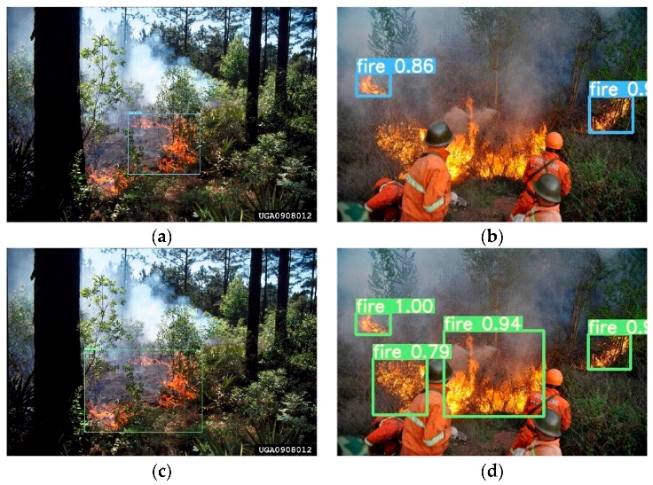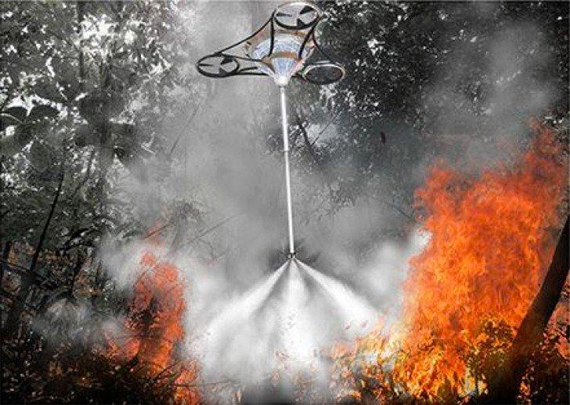

* **Integration of Remote Sensing:** Remote sensing techniques, such as satellite imagery and aerial drones, can be integrated into forest fire detection systems. These technologies can provide a broader perspective and better coverage of large forested areas, allowing for early detection and monitoring of fires.

**CHAPTER - 9**

**VERSION 2.0**

**Integration with Iridium Satellite Constellation**

* **Real-time Monitoring:** Iridium satellites can capture high-resolution imagery of the Earth's surface, enabling real-time monitoring of forested areas. This data can be analyzed to detect the early signs of forest fires, such as smoke plumes, temperature anomalies, or hotspots. By receiving timely information, authorities can quickly respond to potential fire outbreaks, improving the effectiveness of fire management efforts.
* **Global Coverage:** The Iridium satellite constellation consists of multiple satellites that provide global coverage, ensuring that forest fire management systems can monitor and receive data from remote or inaccessible areas. This is particularly useful for monitoring large forested regions, including remote or dense forests, where ground-based systems may have limited reach or face logistical challenges.
* **Improved Communication:** During fire emergencies, effective communication is crucial among firefighters, emergency responders, and management authorities. Iridium satellites enable reliable, low-latency communication channels even in remote areas, where traditional communication infrastructure might be inadequate or damaged. This allows for seamless coordination, timely updates, and resource allocation among teams involved in fire management.
* **Data Transmission:** Forest fire management systems can use Iridium satellites to transmit data from various monitoring sources, such as ground-based sensors, drones, or aerial surveillance platforms. This data can include real-time fire spread information, weather conditions, and other relevant parameters. By efficiently transmitting data to central command centers or decision-making platforms, authorities can make informed decisions and allocate resources effectively.
* **Emergency Response and Evacuation:** Iridium satellites can support emergency response and evacuation efforts during forest fire incidents. By integrating with the satellite network, forest fire management systems can provide real-time updates and warnings to affected communities, emergency services, and individuals in at-risk areas. This helps ensure timely evacuation, minimize casualties, and optimize emergency response actions.
* **Post-Fire Assessment:** After a forest fire, satellite imagery from the Iridium constellation can aid in post-fire assessment and analysis. The high-resolution imagery can be used to assess the extent of the damage, map the burned areas, and identify potential risks such as smoldering hotspots. This information can assist in developing effective rehabilitation and recovery plans for the affected forests.

 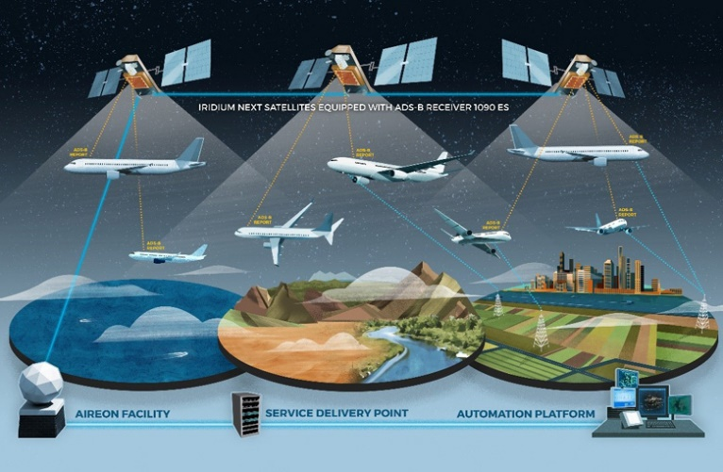

**CHAPTER - 10**

**CONCLUSION**

In conclusion, a comprehensive forest fire management system is crucial for effectively preventing, detecting, and mitigating the devastating impacts of forest fires. By combining proactive measures, advanced technologies, and efficient response strategies, such a system can significantly reduce the occurrence and severity of forest fires, protect lives and property, and preserve the ecological balance of our forests.

* **Prevention:** A strong emphasis on fire prevention through education, public awareness campaigns, and enforcement of regulations is essential. Measures like controlled burns, clearing brush and dead vegetation, and implementing fire-safe practices in high-risk areas can help reduce the likelihood of wildfires starting.
* **Early Detection:** Utilizing cutting-edge technologies such as satellite imagery, remote sensors, and drones equipped with thermal cameras can aid in the early detection of forest fires. This allows for swift response and containment efforts, minimizing the spread and damage caused by wildfires.
* **Monitoring and Surveillance:** Continuous monitoring of forests, including weather conditions, vegetation health, and fire-prone areas, provides valuable data for effective fire management. Integrated systems that collect, analyze, and disseminate information in real-time enable authorities to make informed decisions and allocate resources efficiently.
* **Emergency Response:** A well-coordinated emergency response system is essential to swiftly mobilize firefighting resources, including personnel, vehicles, and equipment, to contain and extinguish wildfires. This involves effective communication and collaboration among firefighters, emergency services, and other relevant stakeholders.
* **Community Engagement:** Engaging local communities and stakeholders in forest fire management efforts fosters a sense of responsibility and ownership. Encouraging community participation, organizing training programs, and establishing partnerships with relevant organizations can enhance fire preparedness and improve response capabilities.
* **Research and Innovation:** Investing in research and development of advanced fire management technologies and strategies is crucial. This includes the development of fire-resistant materials, improved fire behavior modeling, and the use of artificial intelligence for data analysis and prediction.